C.HARSHA VARDHAN REDDY

192111659

CSA1190-OOAD

29-08-2023

**EXP 31 : AGRICULTURE LOAN MANAGEMENT SYSYTEM**

**AIM** : To draw the uml diagram for agriculture loan management system using umbrello.

**USECASE DIAGRAM:**

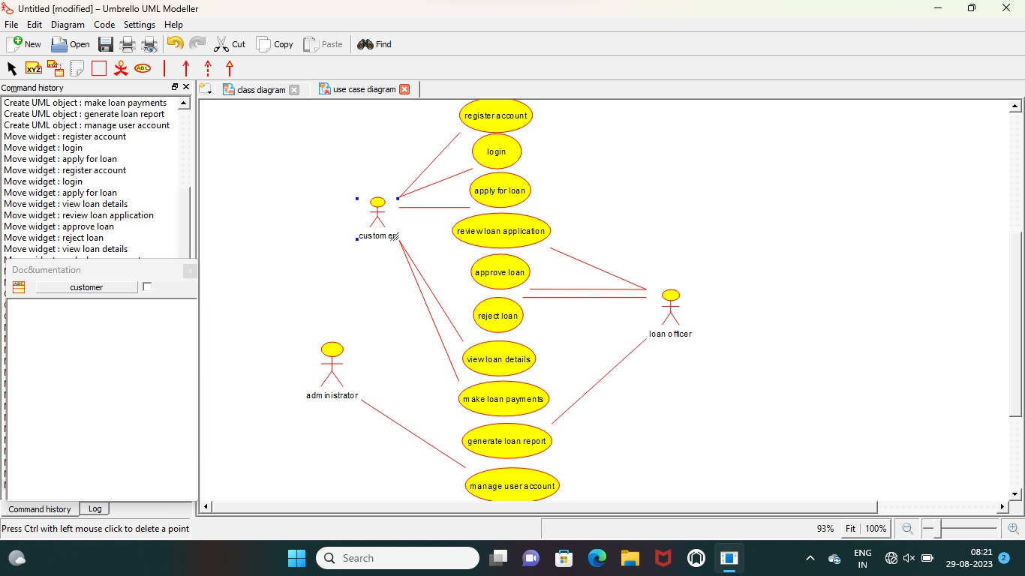

**ACTIVITY DIAGRAM:**

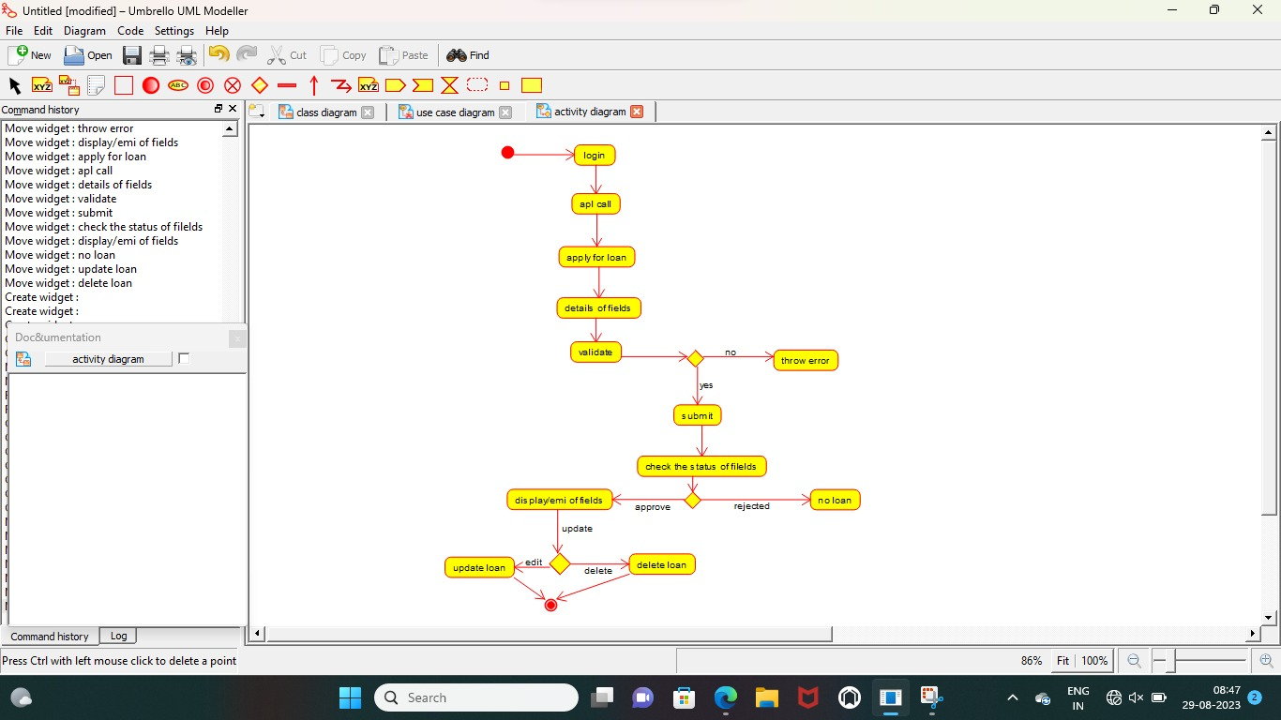

**CLASS DIAGRAM :**

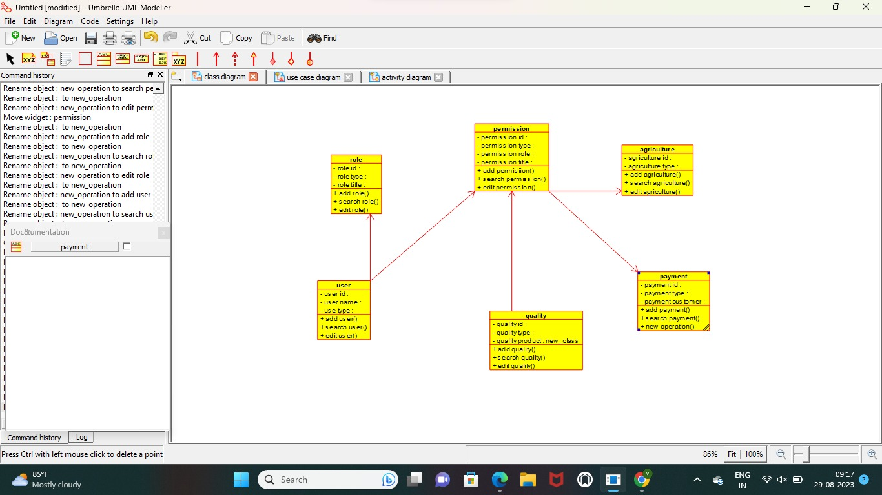

**RESULT** : Program was Executed Successfully using Umbrello**.**

**EXP 32:JEWEL LOAN MANAGMENYT SYSTEM**

**AIM :**  To draw the uml diagram for jewel loan management system using umbrello.

**CLASS DIAGRAM :**

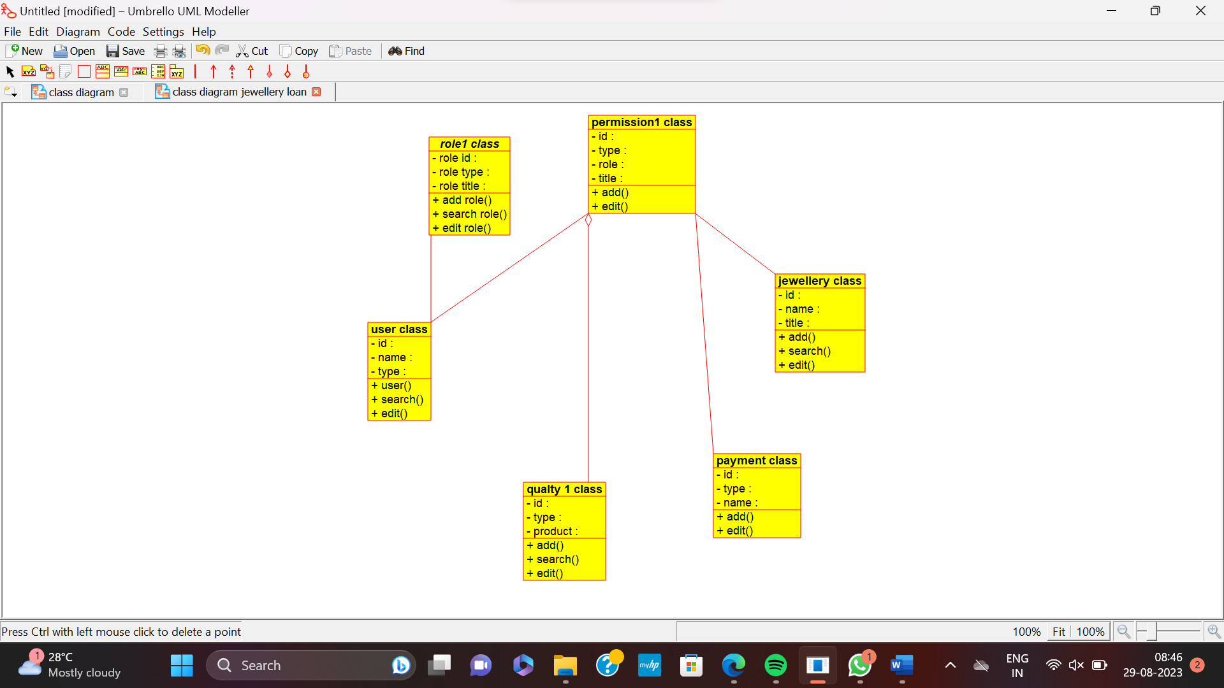

**USE CASE DIAGRAM :**

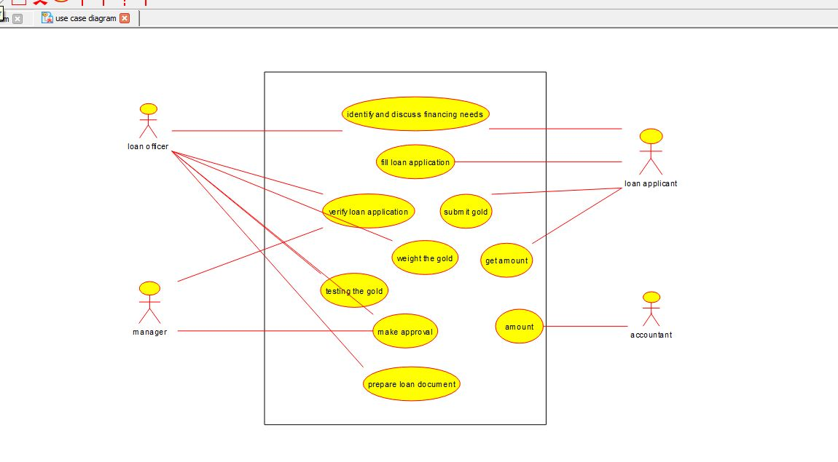

**SEQUENCE DIAGRAM :**

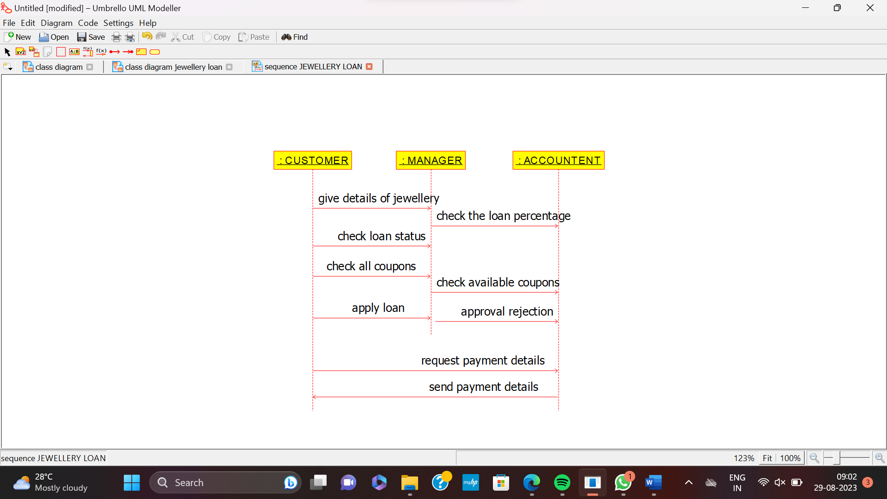

**RESULT** : Program was Executed Successfully using Umbrello**.**

**EXP 33: PERSONAL LOAN MANAGEMENT SYSTEM**

**AIM:** To draw the uml diagram for personal loan management system using umbrello.

**CLASS DIAGRAM**

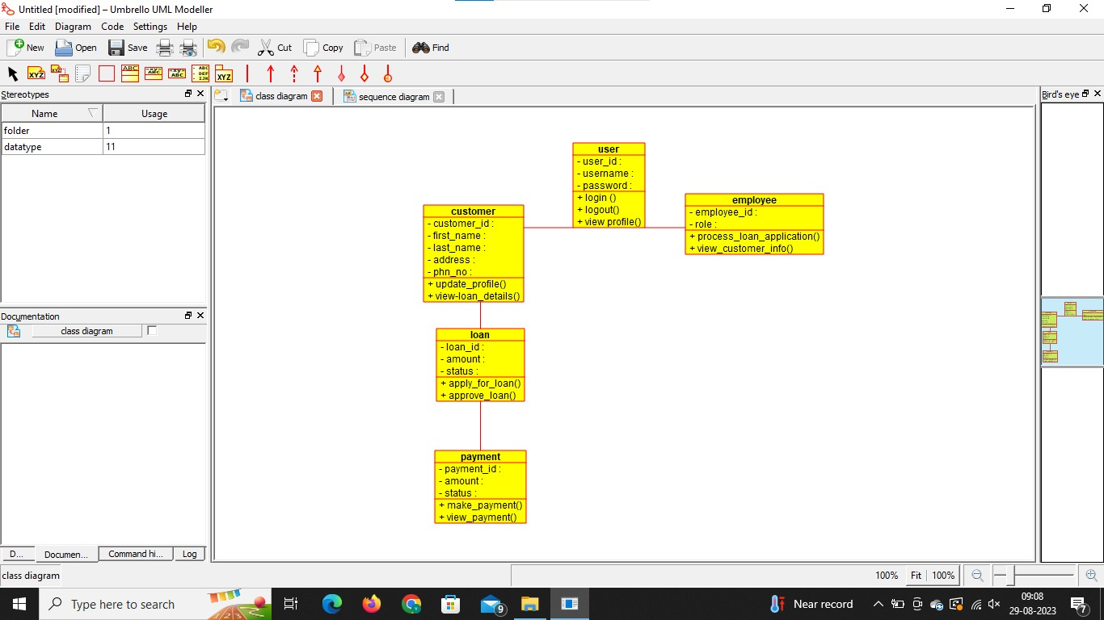

**USECASE DIAGRAM**

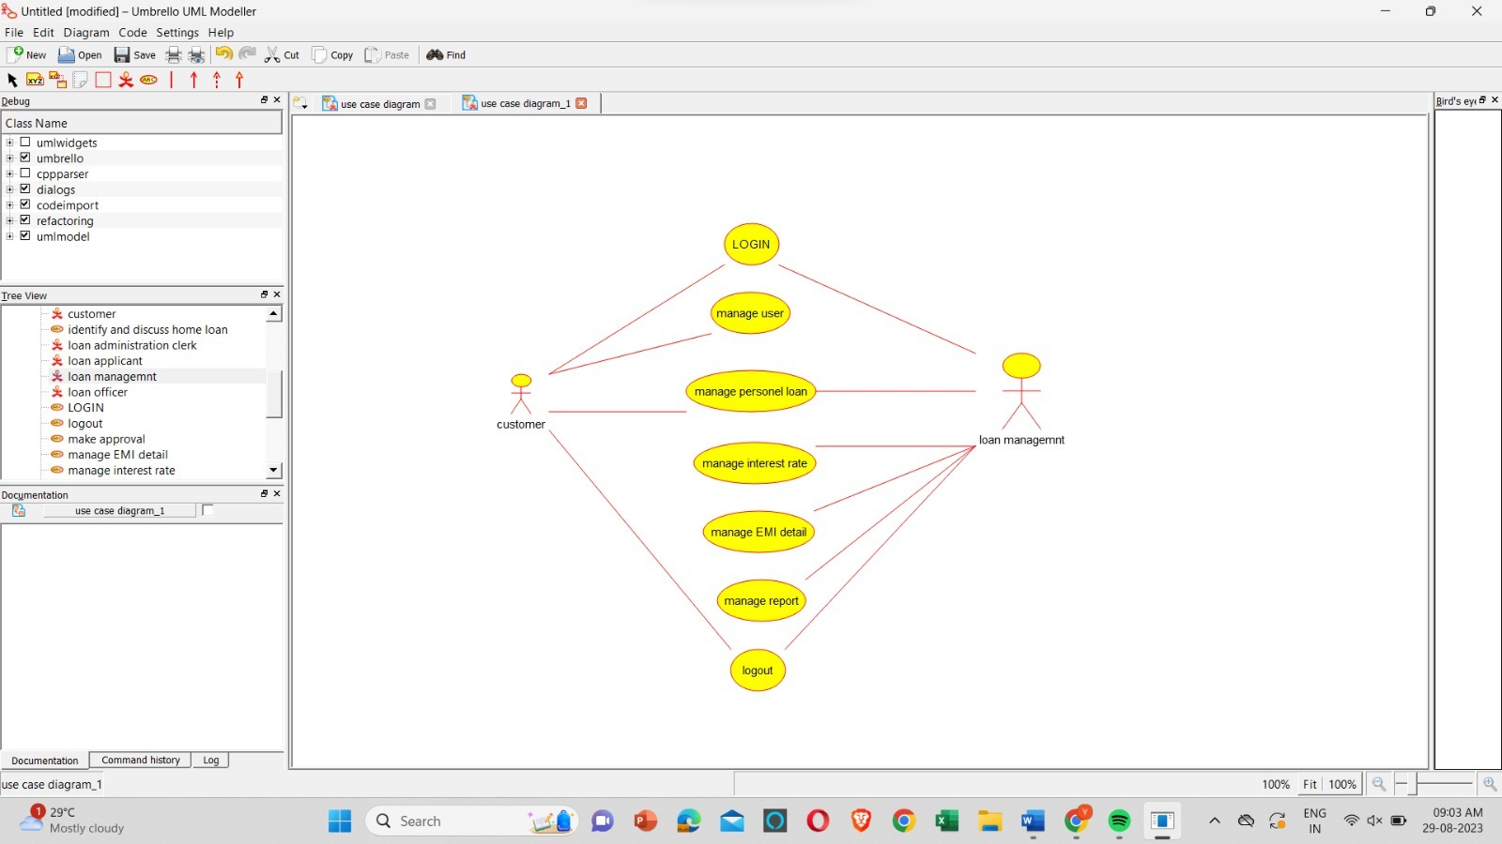

**SEQUENCE DIAGRAM:**

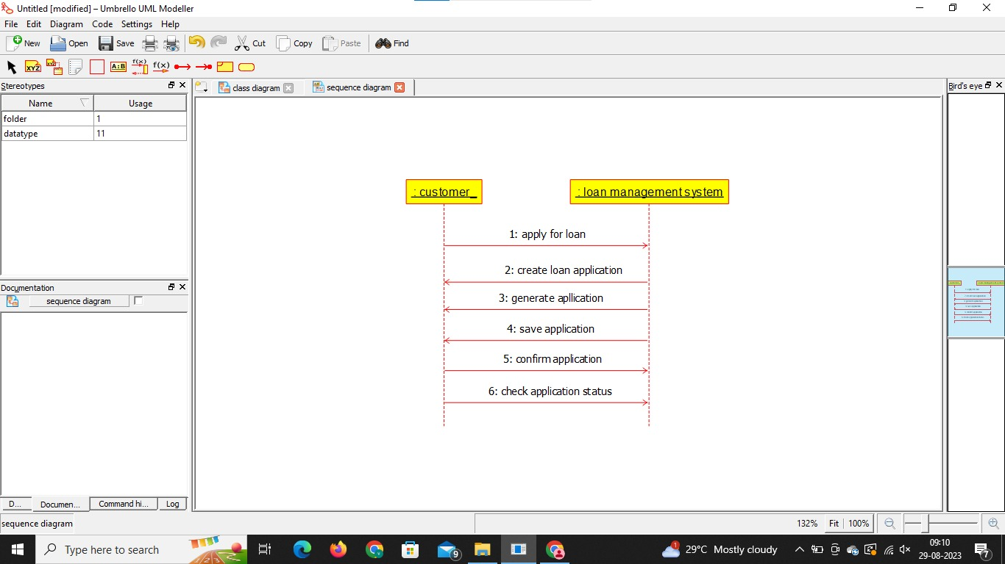

**RESULT** : Program was Executed Successfully using Umbrello**.**

**EXP 34:HOME LOAN MANAGEMENT SYSTEM**

**AIM: :** To draw the uml diagram for home loan management system using umbrello.

**USE CASE DIAGRAM:**

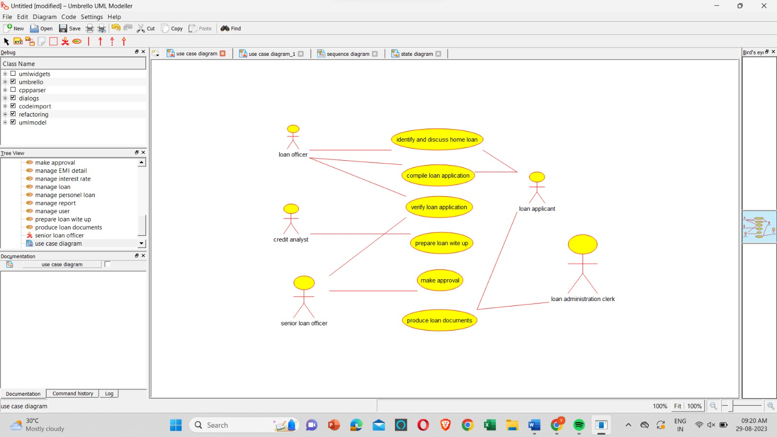

**SEQUENCE DIAGRAM:**

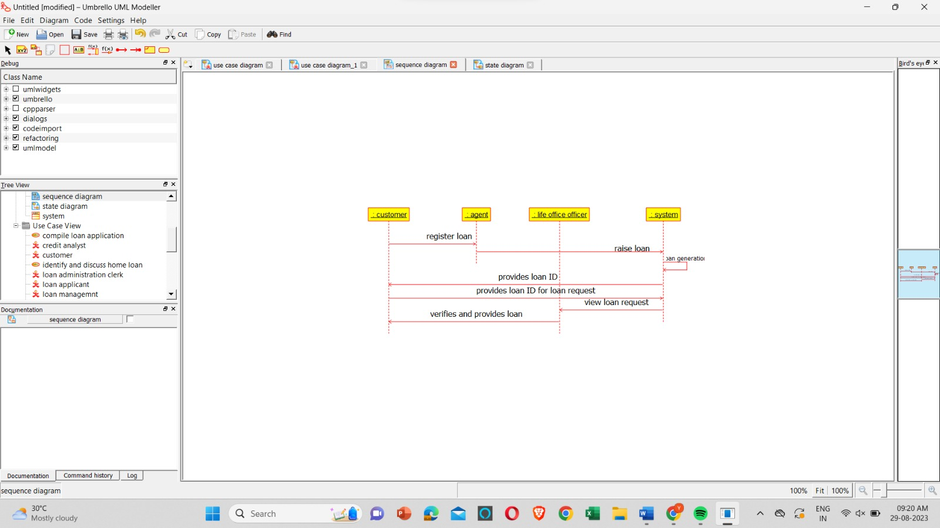

**ACTIVITY DIAGRAM:**

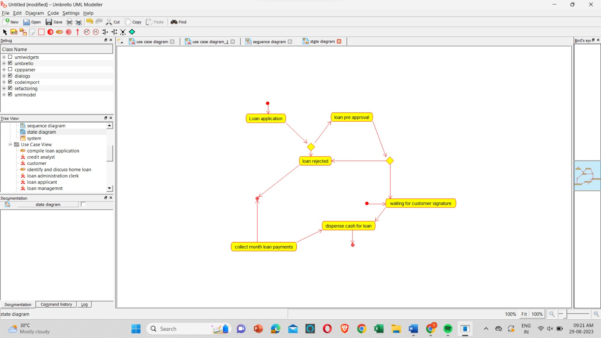

**RESULT** : Program was Executed Successfully using Umbrello.

**EXP35: LAND REGISTRATION SYSTEM**

**AIM:** To draw the uml diagram for home loan management system using umbrello.

**SEQUENCE DIAGRAM:**

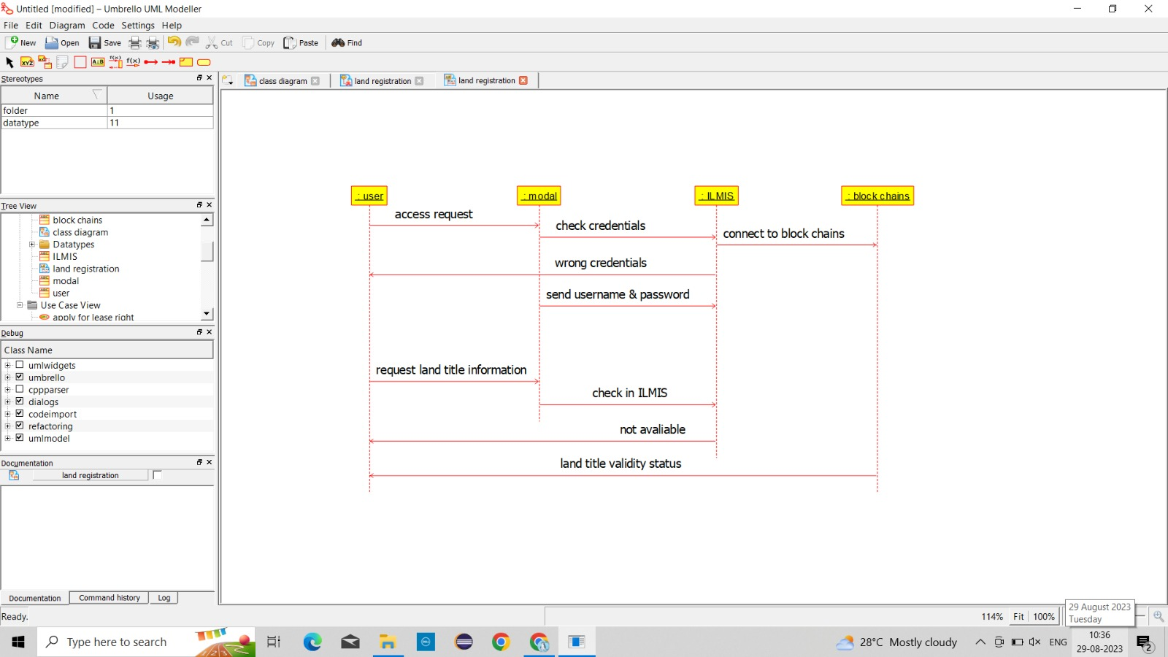

**USE CASE DIAGRAM:**

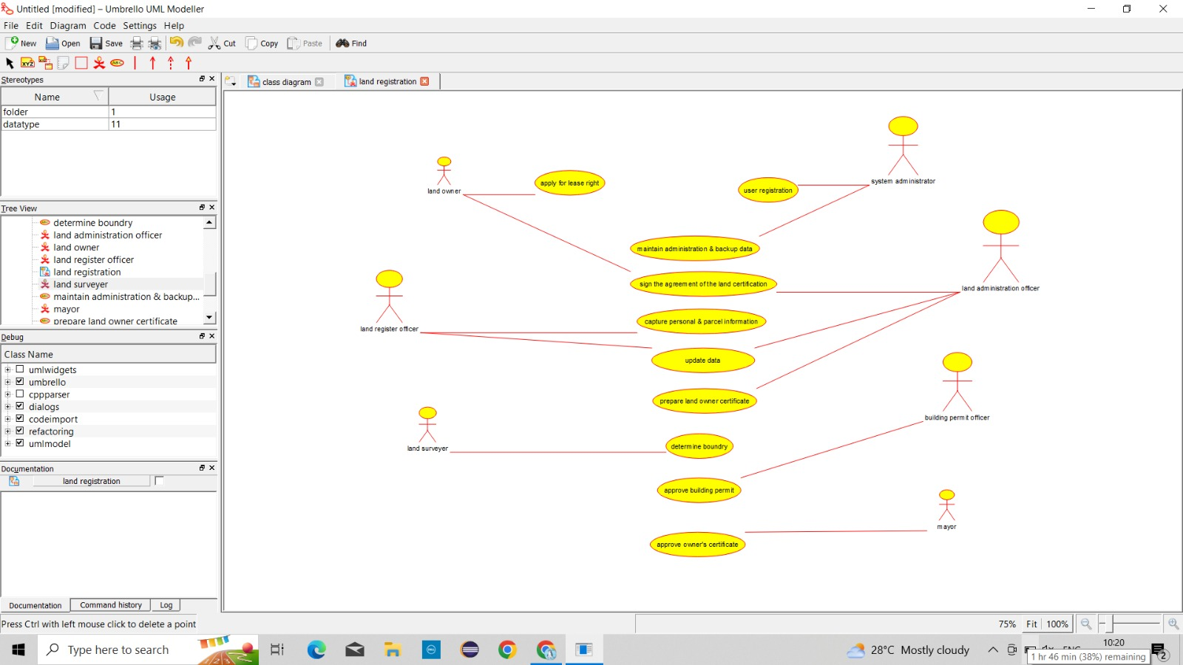

**ACTIVITY DIAGRAM:**

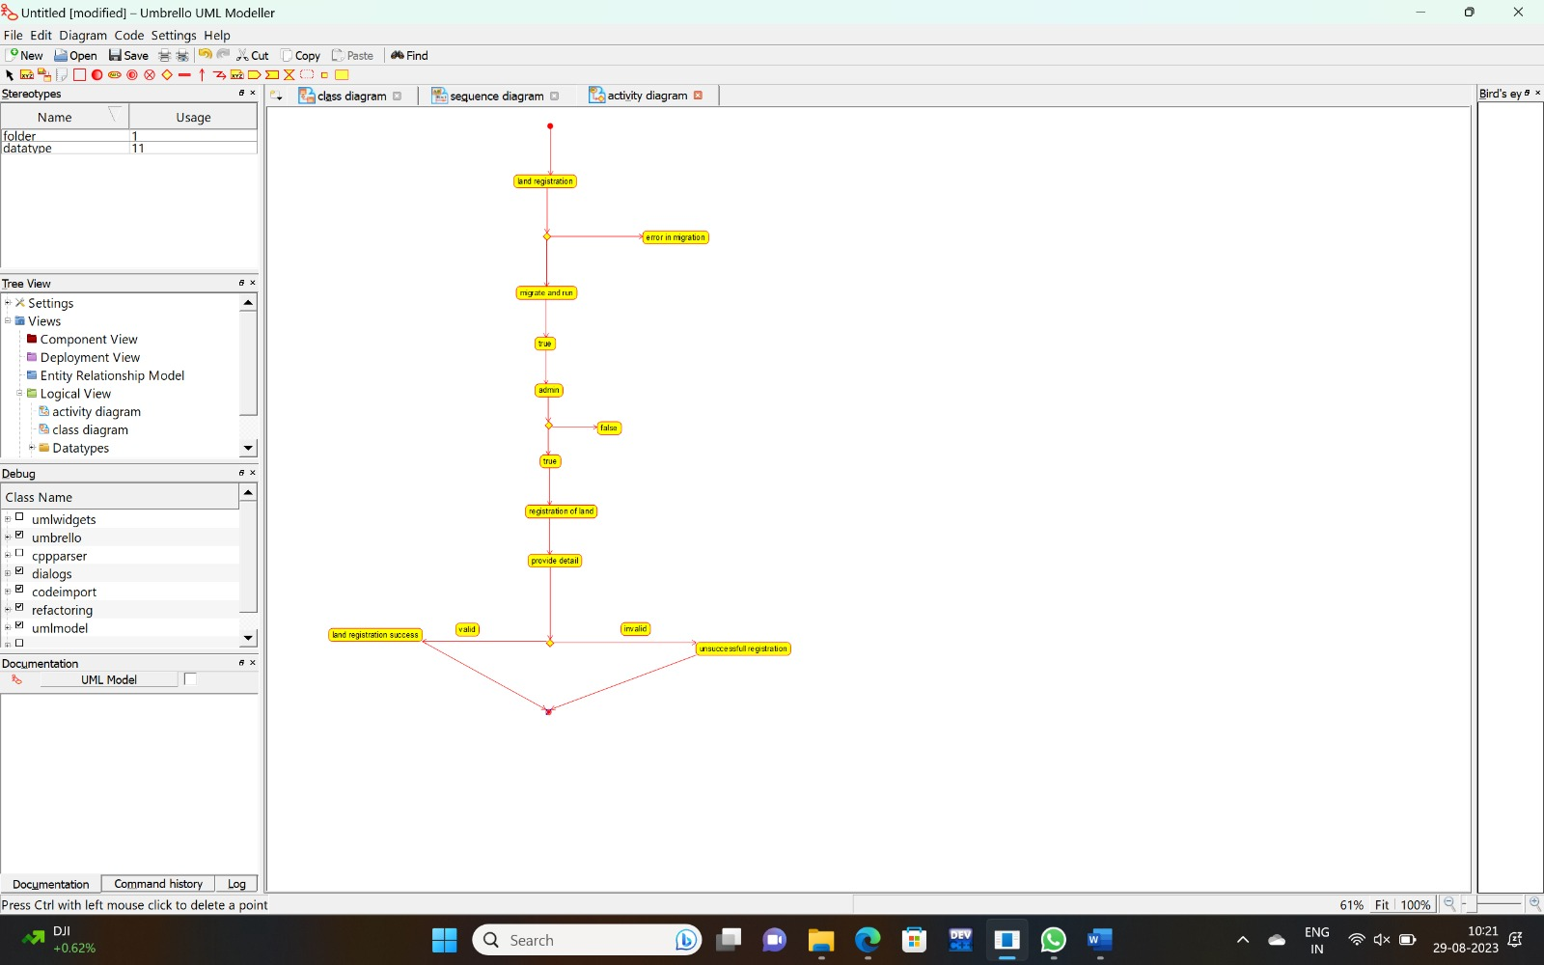

**RESULT** : Program was Executed Successfully using Umbrello.

**EXP 36: VEHICLE BOOKING SYSTEM**

**AIM:** To draw the uml diagram for vehicle booking system using umbrello.

**COMPONENT DIAGRAM:**

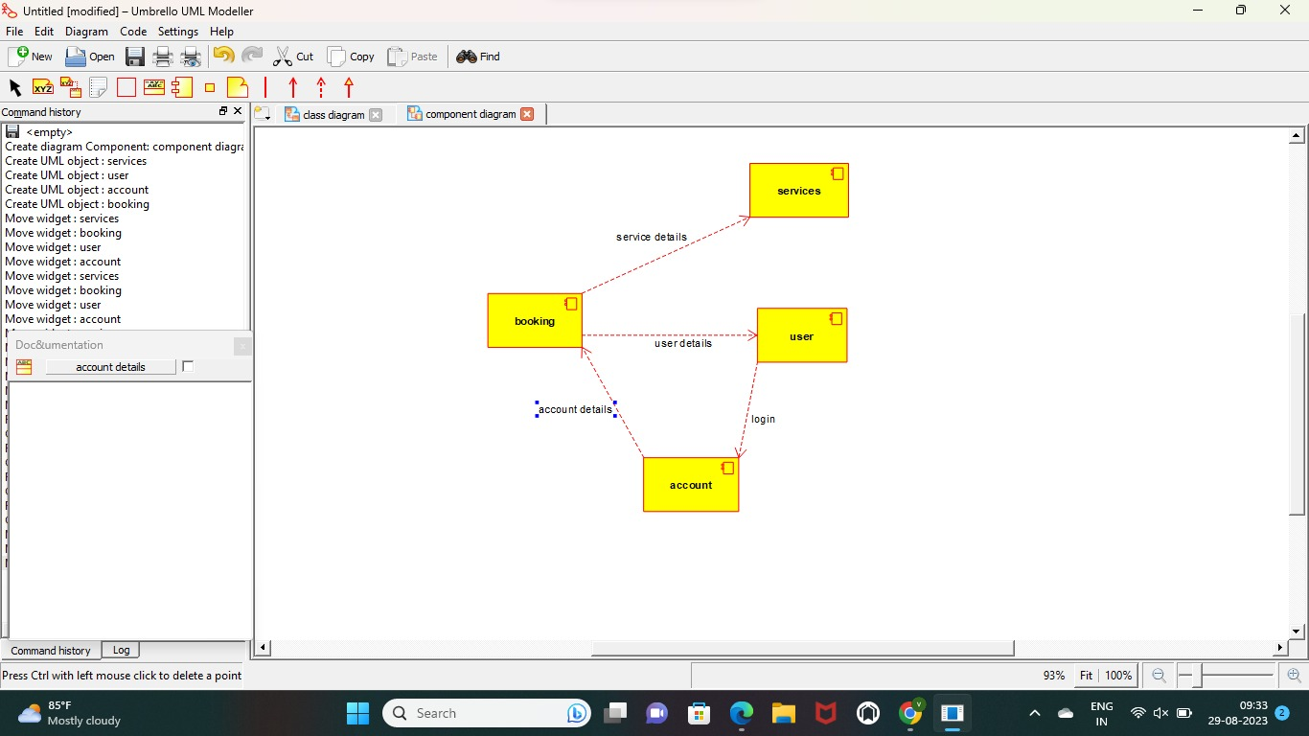

**USECASE DIAGRAM:**

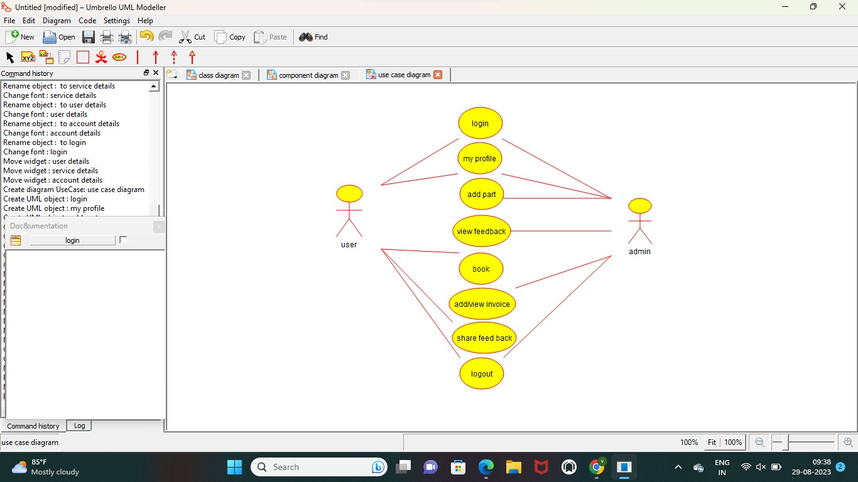

**SEQUENCE DIAGRAM:**

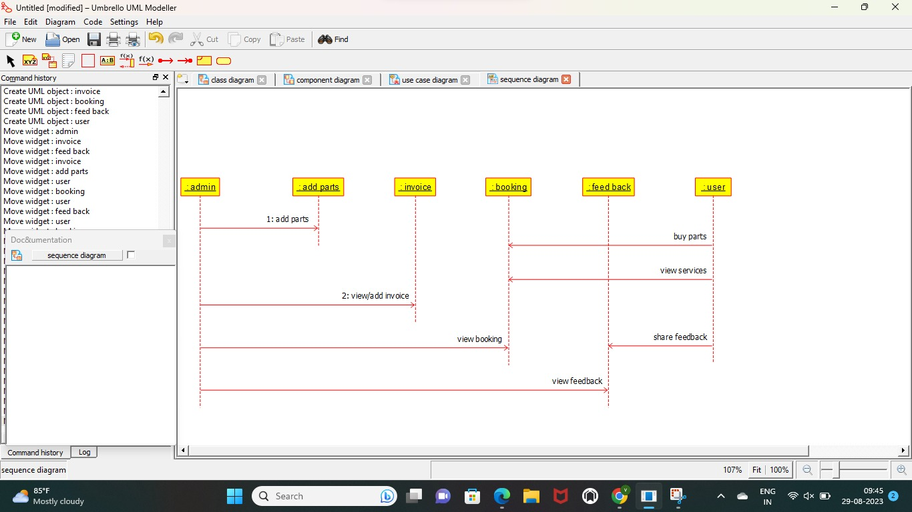

**RESULT** : Program was Executed Successfully using Umbrello.

**EXP 37:DOCTOR APPOINTMENTSYSTEM**

**AIM:** To draw the uml diagram for doctor appointment system using umbrello.

**SEQUENCE:**

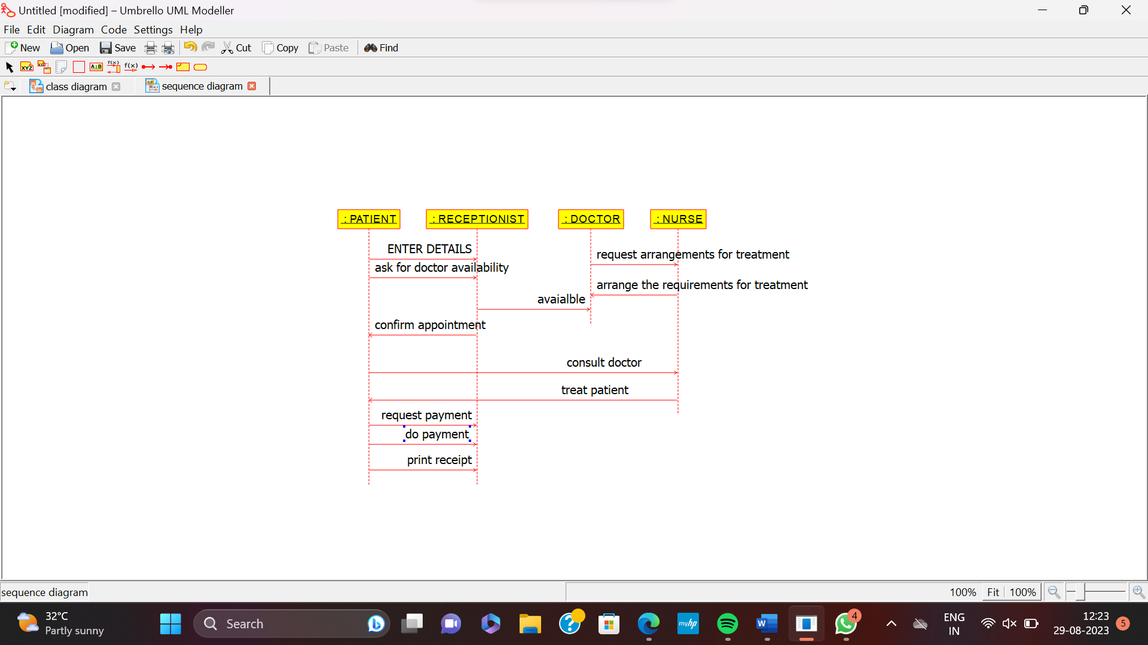

**USE CASE:**

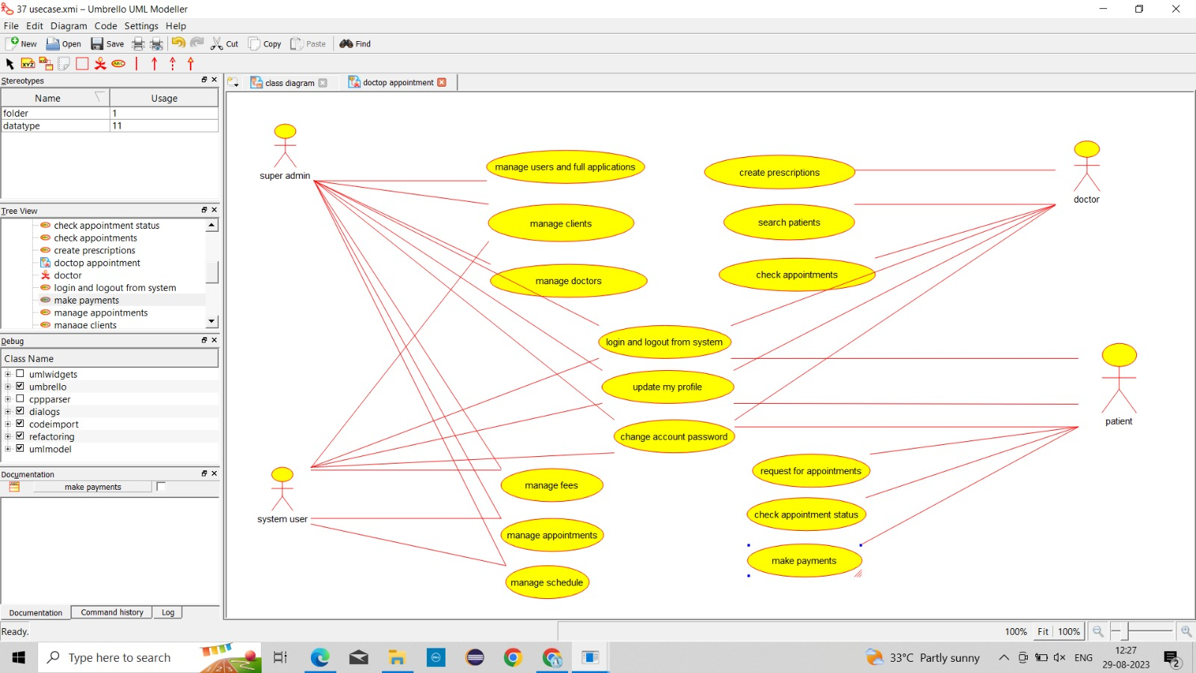

**ACTIVITY:**

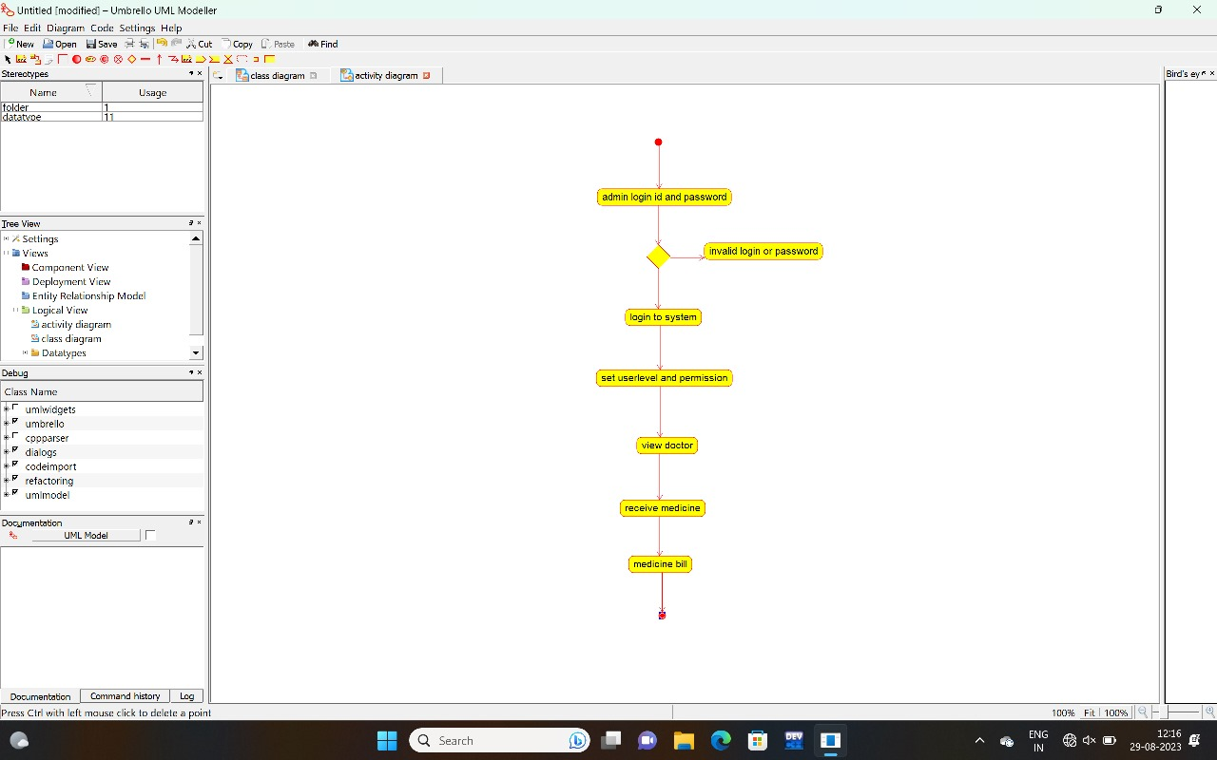

**RESULT** : Program was Executed Successfully using Umbrello.

**Exp 38: BEAUTY PARLOUR RESERVATION SYSTEM**

**AIM:** To draw the uml diagram for beauty parlour reservation system using umbrello.

**ACTIVITY:**

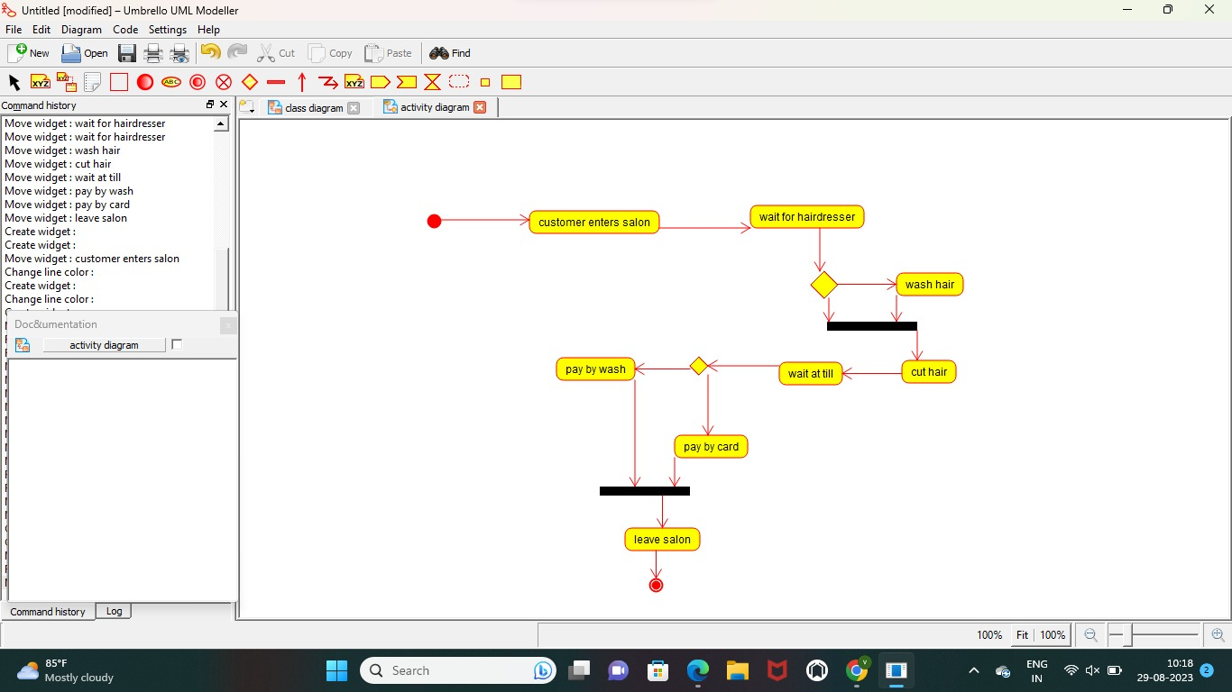

**SEQUENCE:**

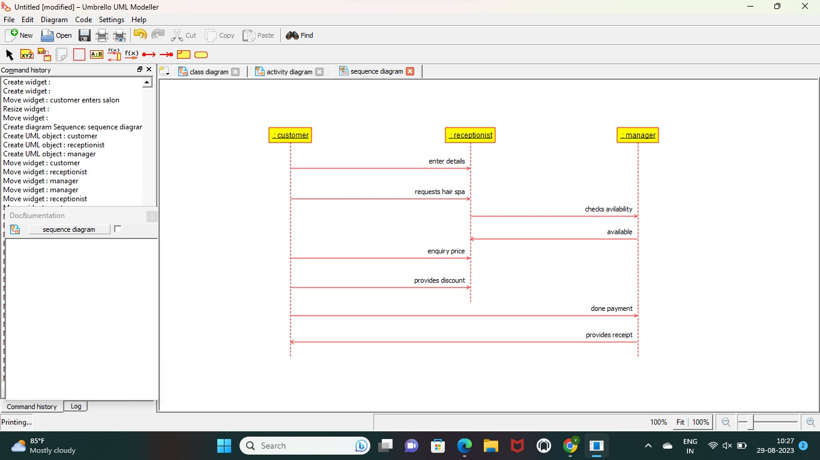

**CLASS**

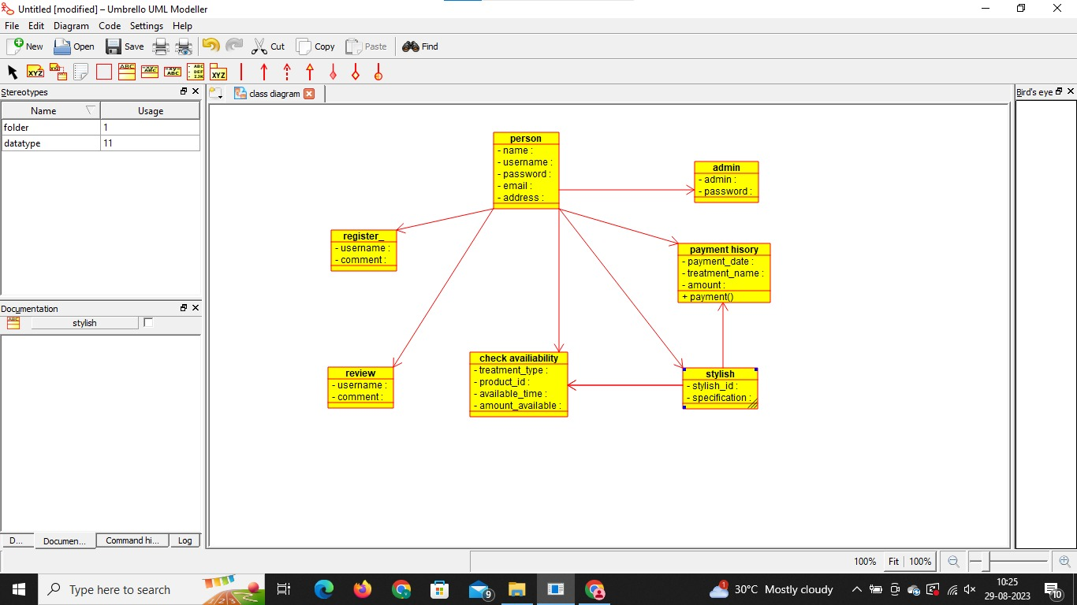

**RESULT** : Program was Executed Successfully using Umbrello.

**Exp 39:GARDENER BOOKING SYSTEM**

**AIM:** To draw the uml diagram for beauty gardener booking system using umbrello.

**COMPONENT:**

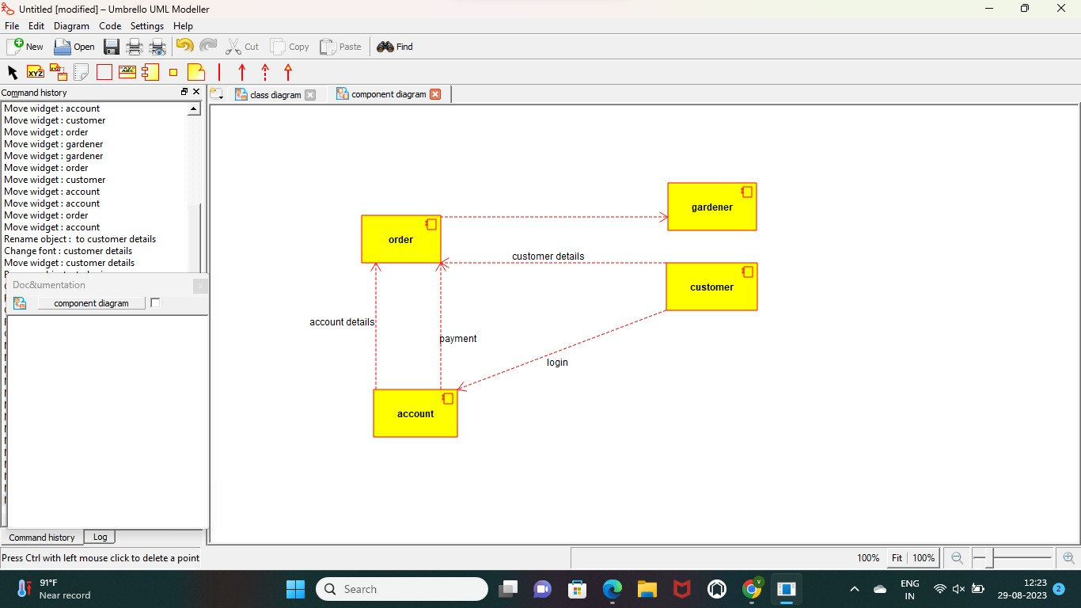

**USE CASE:**

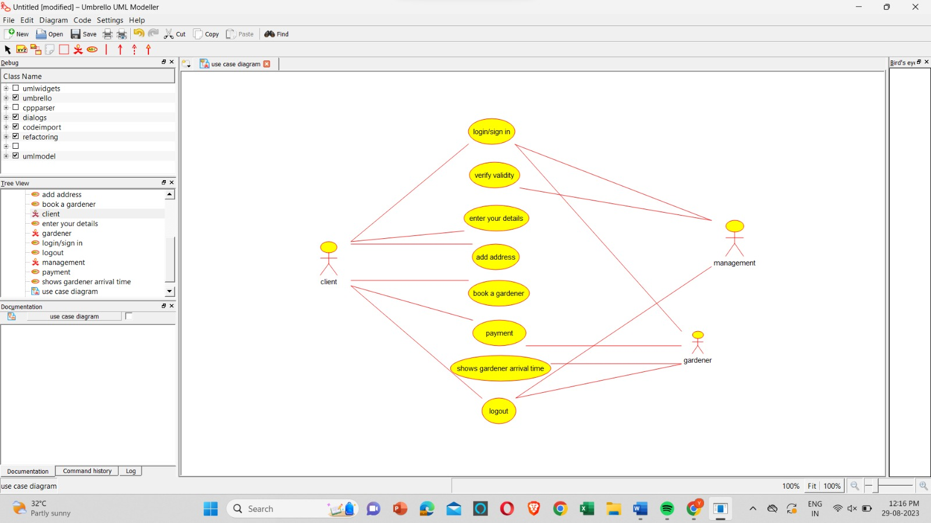

ACTIVITY:

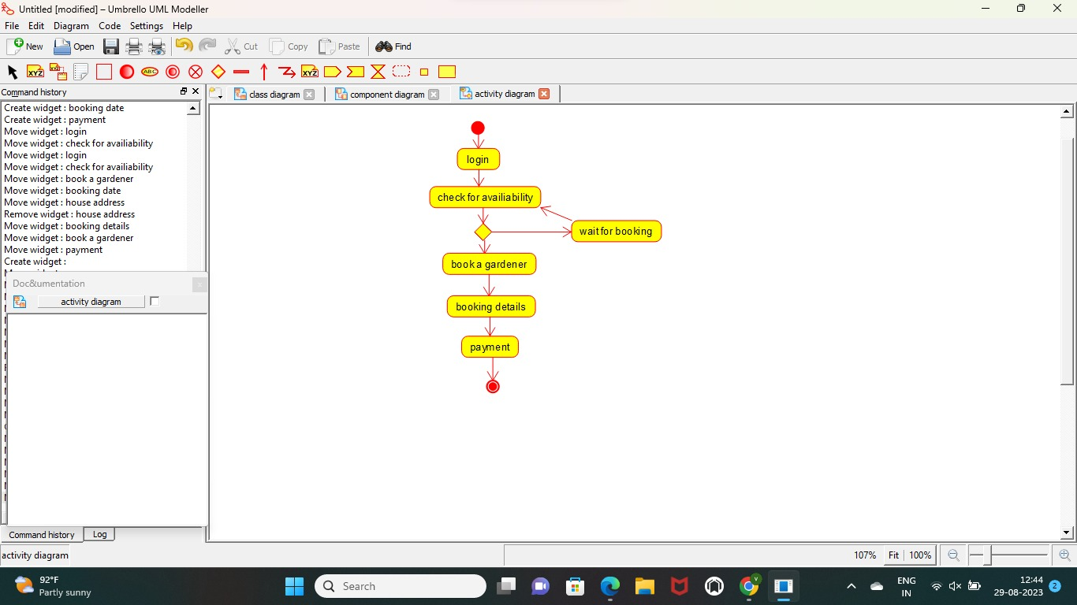

**RESULT** : Program was Executed Successfully using Umbrello.

**Exp 40:HOME TAX COLLECTION SYSTEM**

**AIM:** To draw the uml diagram for home tax collection system using umbrello.

**USECASE:**

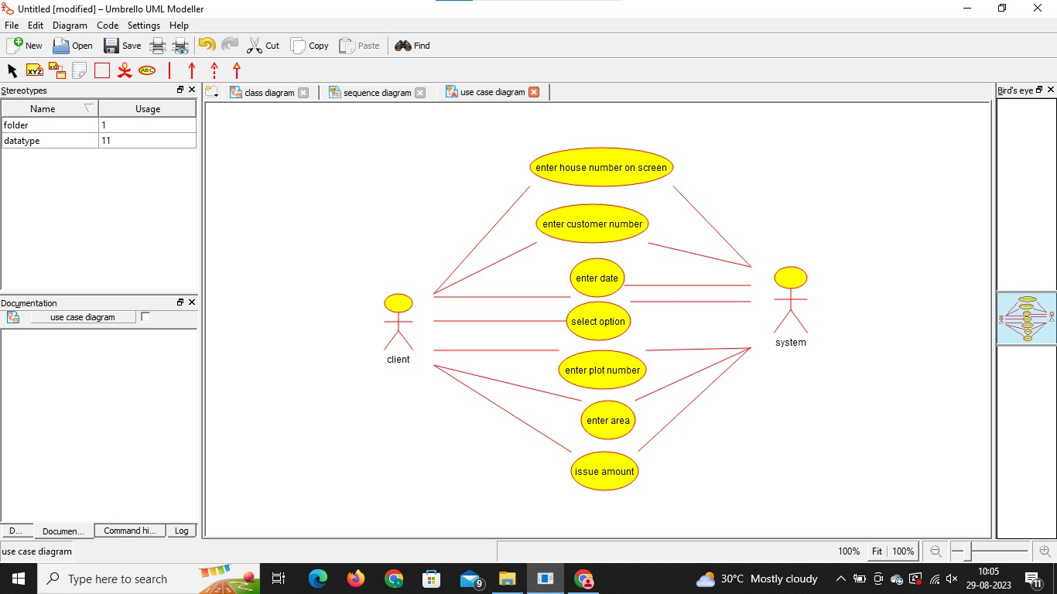

**SEQUENCE:**

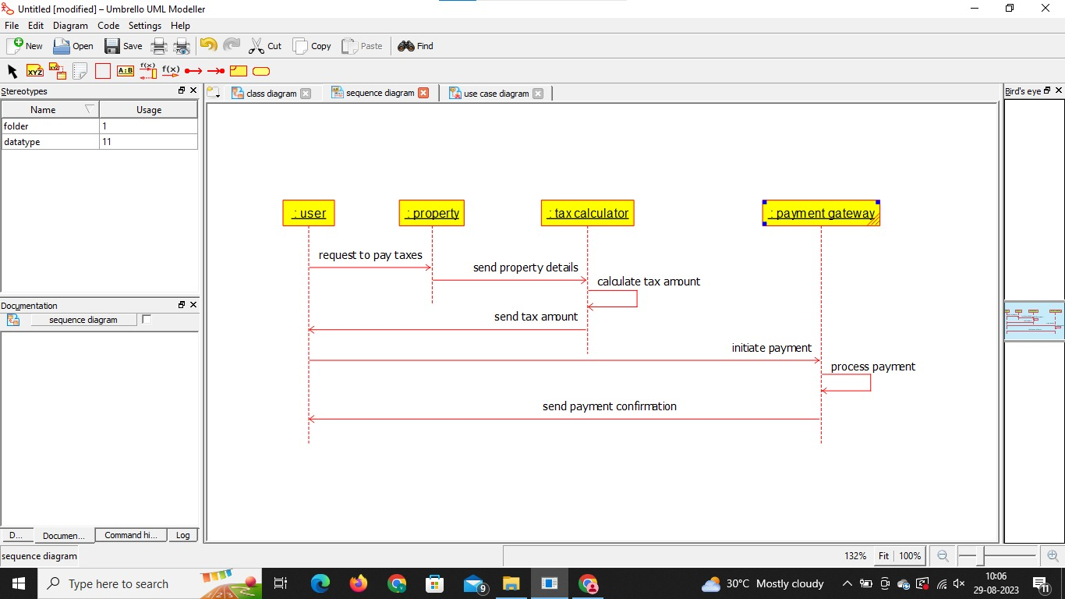

**CLASS:**

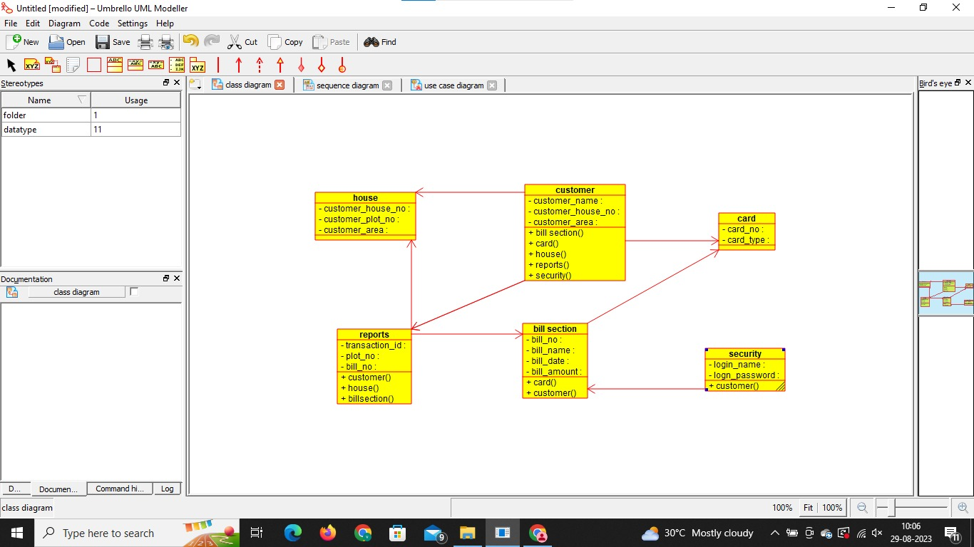

**RESULT** : Program was Executed Successfully using Umbrello.